**Front-side of Story Card**

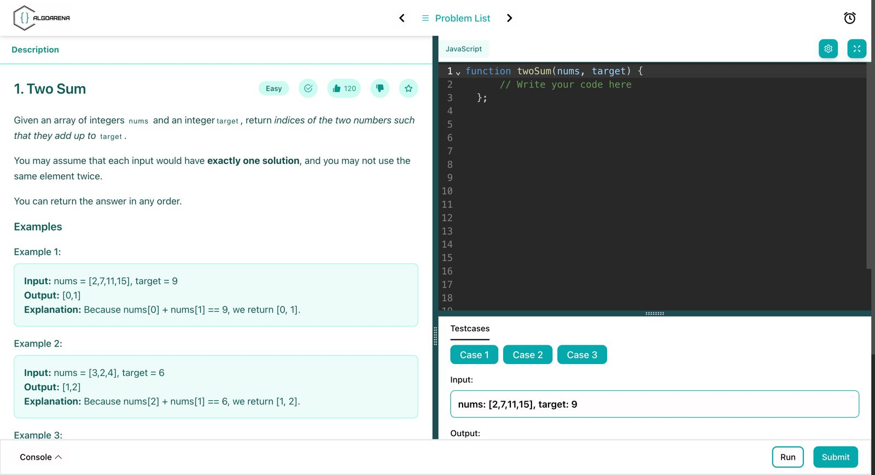

**As a User,**

**I want to submit my solutions,**

**So that they can be evaluated automatically.**

**Backside of the story card**

| Success Conditions   * Submissions are evaluated against test cases with clear results. * Feedback is provided for both success and failure.   Failure Conditions   * Submissions are not evaluated or no feedback is given. * Incorrect results are shown for valid solutions. |
| --- |